**Week 1: Introduction to Networking & Network Security**

**Objective:** Understand basic network components, models, and security principles.

**Task # 04: Install and explore Wireshark — capture live network traffic and analyze a simple HTTP request.**

**Solution:**

1. The small graphs next to interfaces like "Wi-Fi" and "VMware Network Adapter VMnet3" indicate **live network activity** on those specific interfaces, suggesting they are currently active and transmitting/receiving data.

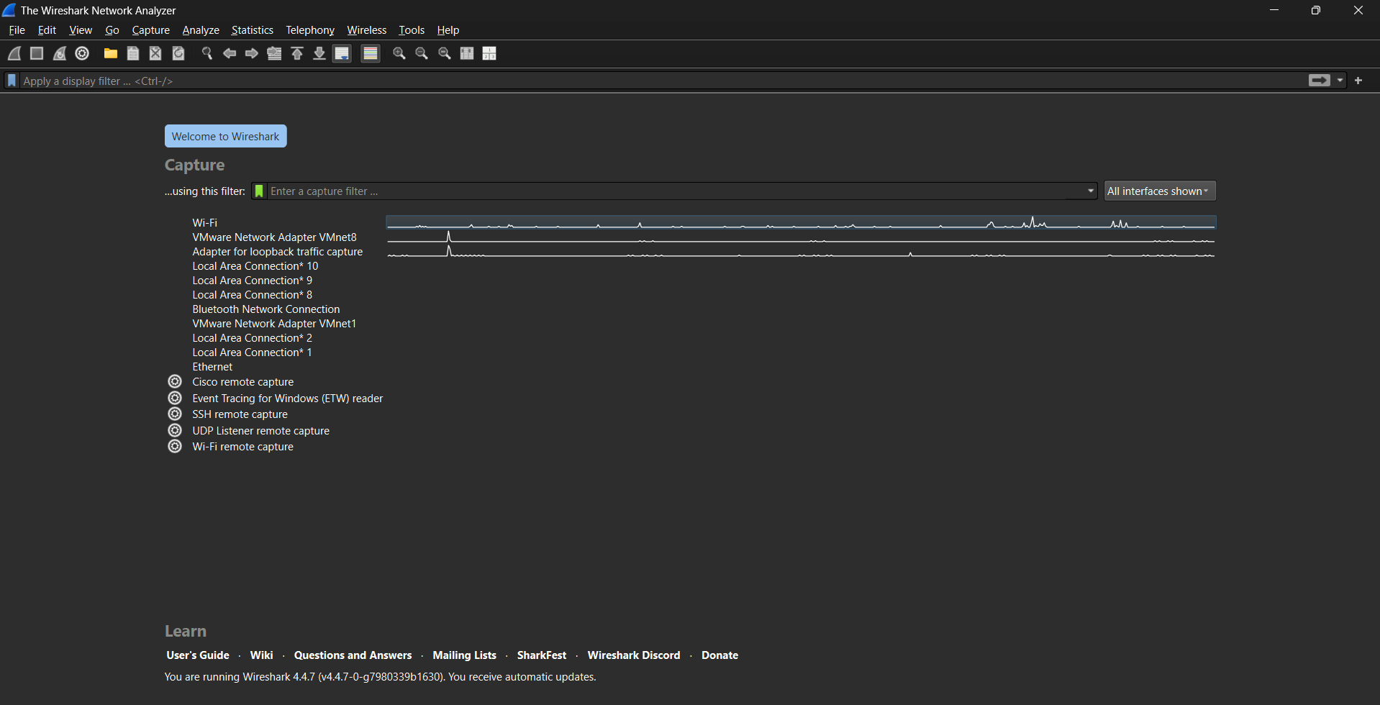

1. This Wireshark screenshot shows captured internet traffic. Most of it is encrypted (TLSv1.3), but the details reveal a successful web page download. We can see an HTTP "200 OK" response, meaning the request worked. This demonstrates how Wireshark lets you peek at what's happening on your network.

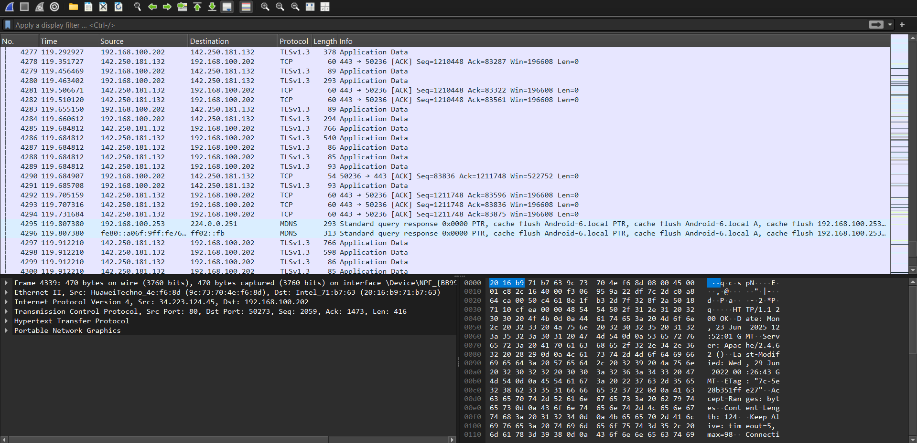

1. This Wireshark screenshot displays captured web traffic, with an **HTTP display filter applied**. It clearly shows multiple **HTTP GET requests** and their **200 OK responses** from http://neverssl.com. The expanded section details the HTTP request headers, demonstrating successful unencrypted web communication analysis.

